Mobile Routers
# Source: Chatgpt (GPT-5-Mini) at [1/23/2026]
A mobile router (also known as a portable Wi-Fi router, MiFi, or mobile hotspot) is a small wireless device that connects to a cellular mobile network (3G, 4G, 5G) and shares that internet connection over Wi-Fi with multiple nearby devices like phones, laptops, or tablets.

Mobile Routers photo
# Source: Windows Screenshots (using Lightshot Program) at [1/23/2026]
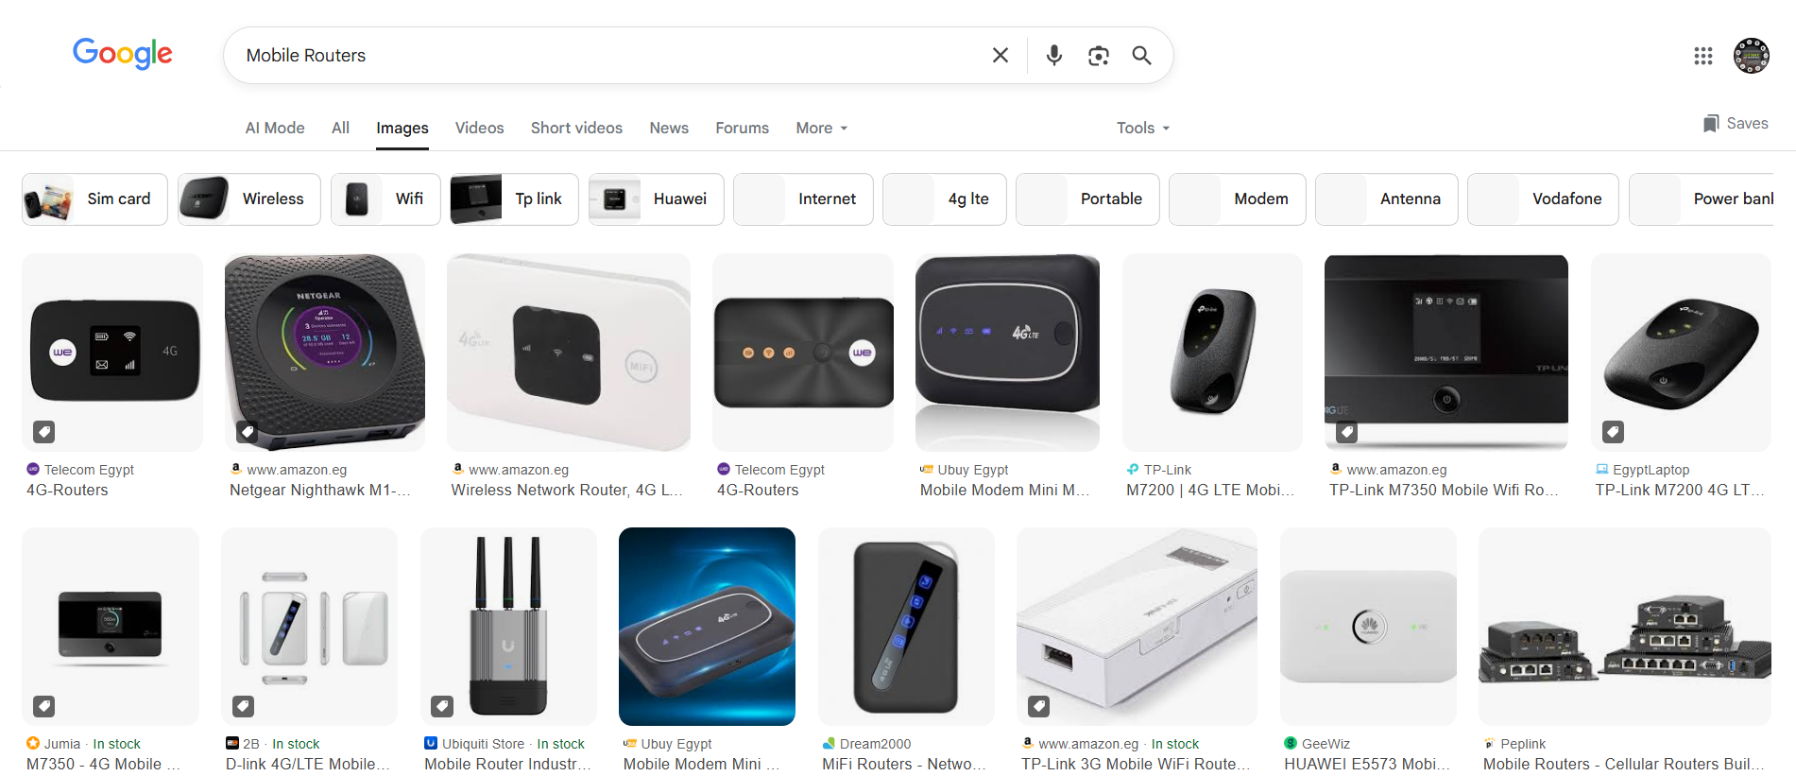

🔑 Key Features of Mobile Routers:
# Source: Chatgpt (GPT-5-Mini) at [1/23/2026]
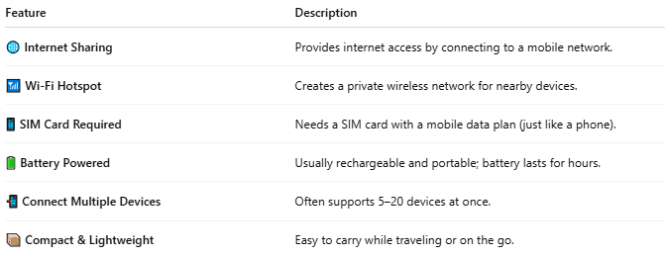

Feature | Description
🌐 Internet Sharing | Provides internet access by connecting to a mobile network.
📶 Wi-Fi Hotspot | Creates a private wireless network for nearby devices.
📱 SIM Card Required | Needs a SIM card with a mobile data plan (just like a phone).
🔋 Battery Powered | Usually rechargeable and portable; battery lasts for hours.
📲 Connect Multiple Devices | Often supports 5–20 devices at once.
📦 Compact & Lightweight | Easy to carry while traveling or on the go.

🧩 Common Uses of Mobile Routers:
# Source: Chatgpt (GPT-5-Mini) at [1/23/2026]
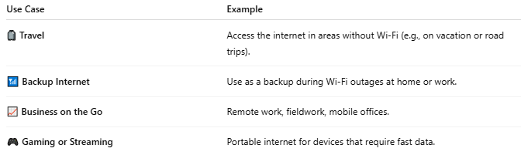

Use Case | Example
🧳 Travel | Access the internet in areas without Wi-Fi (e.g., on vacation or road trips).
📶 Backup Internet | Use as a backup during Wi-Fi outages at home or work.
📈 Business on the Go | Remote work, fieldwork, mobile offices.
🎮 Gaming or Streaming | Portable internet for devices that require fast data.

📡 Mobile Router vs Smartphone Hotspot:
# Source: Chatgpt (GPT-5-Mini) at [1/23/2026]
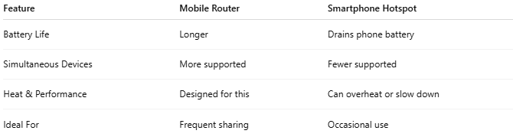

Feature | Mobile Router | Smartphone Hotspot
Battery Life | Longer | Drains phone battery
Simultaneous Devices | More supported | Fewer supported
Heat & Performance | Designed for this | Can overheat or slow down
Ideal For | Frequent sharing | Occasional use

📖 Summary:
# Source: Chatgpt (GPT-5-Mini) at [1/23/2026]
A mobile router is a wireless device that turns cellular data into a Wi-Fi signal, letting you connect laptops, tablets, or other devices to the internet wherever there's mobile coverage.

